**Digital Habits and Exercise: Impacts on Morning Freshness and Mental Well-being**

*Tiya Chokhani*

**Introduction**

In the realm of mental health and well-being, understanding factors that influence our sense of refreshment and rest upon waking is crucial. This paper delves into the research of three distinct interventions: the impact of exercise, the effect of scrolling through social media before bedtime, and the influence of engaging with social media immediately upon waking. The need for this research stems from the growing awareness of how lifestyle choices and digital interactions shape our mental health, particularly in relation to sleep quality and morning freshness. The reason I chose to study the effect of these interventions on how fresh and rested I felt in the morning was that I’ve realized that the tone of my entire day seems profoundly influenced by how I feel when I wake up so by investigating the impact of these activities, my goal is not only to gain academic insight but also to find practical ways to enhance my own life and potentially the lives of others.

I propose that 30 minutes of daily exercise will lead to improved feelings of freshness and restfulness the next morning, in line with Saidi et al. (2021), who found exercise significantly enhances sleep quality and overall well-being. Additionally, my second and third hypotheses suggest that scrolling through social media before bedtime or immediately upon waking negatively impacts morning freshness. This is supported by Kazhali’s 2021 study, which associates high social media use, particularly before sleep, with reduced sleep quality, especially in younger demographics like college students. Complementing this, a systematic review by Alonzo, Hussain, et al., connects excessive social media use with poor sleep quality and adverse mental health outcomes, emphasizing the detrimental effects of social media usage near sleeping and waking times.

**Methods**

1. **Exercise**

I undertook a structured exercise regimen, spending 60 minutes at the Bruin Fitness gym from 5 - 6 pm on three consecutive days within one week. Each session included a fixed routine: 20 minutes of cardio, 30 minutes of weight training, and 10 minutes of stretching, I diligently noted how fresh and rested I felt when I woke up (“I woke up feeling fresh and rested”), every night before going to sleep on a scale ranging from 1 to 7, where 1 was a strong disagreement – not feeling rested or fresh at all – and 7, a strong agreement – feeling very fresh and rested. For two days, the data recording occurred with a delay, being noted the following morning instead of the same night. This information was collected using a Google form which enabled me to compare how fresh and rested I felt after days with exercise (n=3) versus days without any physical activity (n=3).

1. **Social Media before bed**

I spent a minimum of 15 minutes on Instagram and TikTok before bedtime on three different days within a week. To maintain consistency, I scrolled at similar times and under similar conditions each day. My sleep times varied between 12 am and 2 am and I woke up between 9 and 10 am daily. I diligently noted how fresh and rested I felt when I woke up (“I woke up feeling fresh and rested”), every night before going to sleep on a scale ranging from 1 to 7, where 1 was a strong disagreement – not feeling rested or fresh at all – and 7, a strong agreement – feeling very fresh and rested. At the end of the week, I uploaded this data via a Google form. This process allowed me to compare my feelings of freshness and restfulness upon waking after intervention days (n=3) and non-intervention days (n=3).

1. **Social Media after waking up**

Over two weeks, I conducted an intervention by scrolling on Instagram and TikTok for at least 30 minutes on six different days. To ensure consistency, I scrolled at similar times under the same conditions. I narrowed my bedtime range to between 12:30 am and 1 am, waking up at 9:30 am daily, to control for sleep duration—a limiting factor in previous studies. I diligently noted how fresh and rested I felt when I woke up (“I woke up feeling fresh and rested”), every night before going to sleep on a scale ranging from 1 to 7, where 1 was a strong disagreement – not feeling rested or fresh at all – and 7, a strong agreement – feeling very fresh and rested. At the end of the week, I uploaded this data via a Google form. This method allowed me to compare my feelings of freshness and restfulness after intervention days (n=6) and non-intervention days (n=6).

**Results**

1. **Exercise**

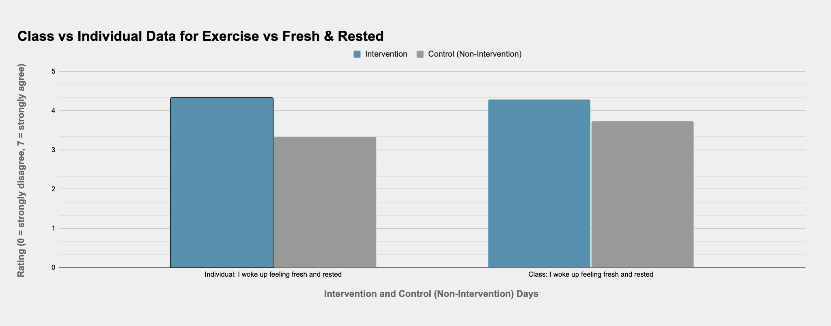

On days I didn't exercise how fresh I felt was at a mean of 4, as compared to on the days I did the mean score was at 5.67. At the same time, the standard deviation on intervention days and control days was 0.577. To get a better understanding I’ll also be looking at class data for the intervention which had a mean ‘I woke up feeling fresh and rested’ score of 4.29 on intervention days and a mean score of 3.73 on control days.

1. **Social Media before bed**

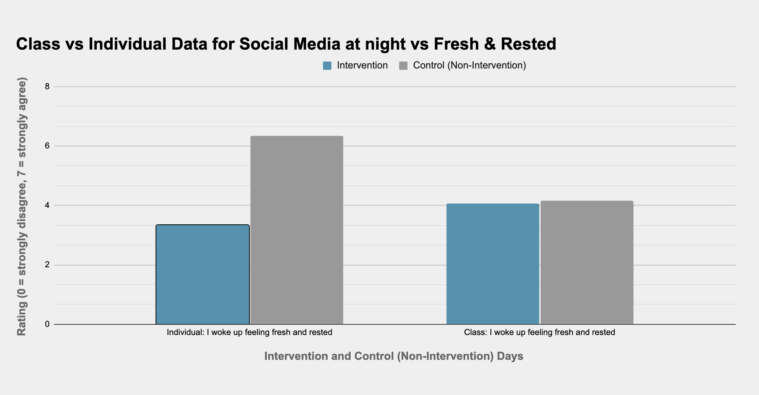

On days I didn't use social media before bed how fresh and rested I woke up the next day had a mean of 6.33 and a standard deviation of ​​0.47, as compared to on the days I did the score was at 3.33 and the standard deviation was 0.47. To get a better understanding I’ll also be looking at class data for the intervention which had a mean ‘I woke up feeling fresh and rested’ score of 4.07 on intervention days and a mean score of 4.17 on control days.

1. **Social Media in the morning**

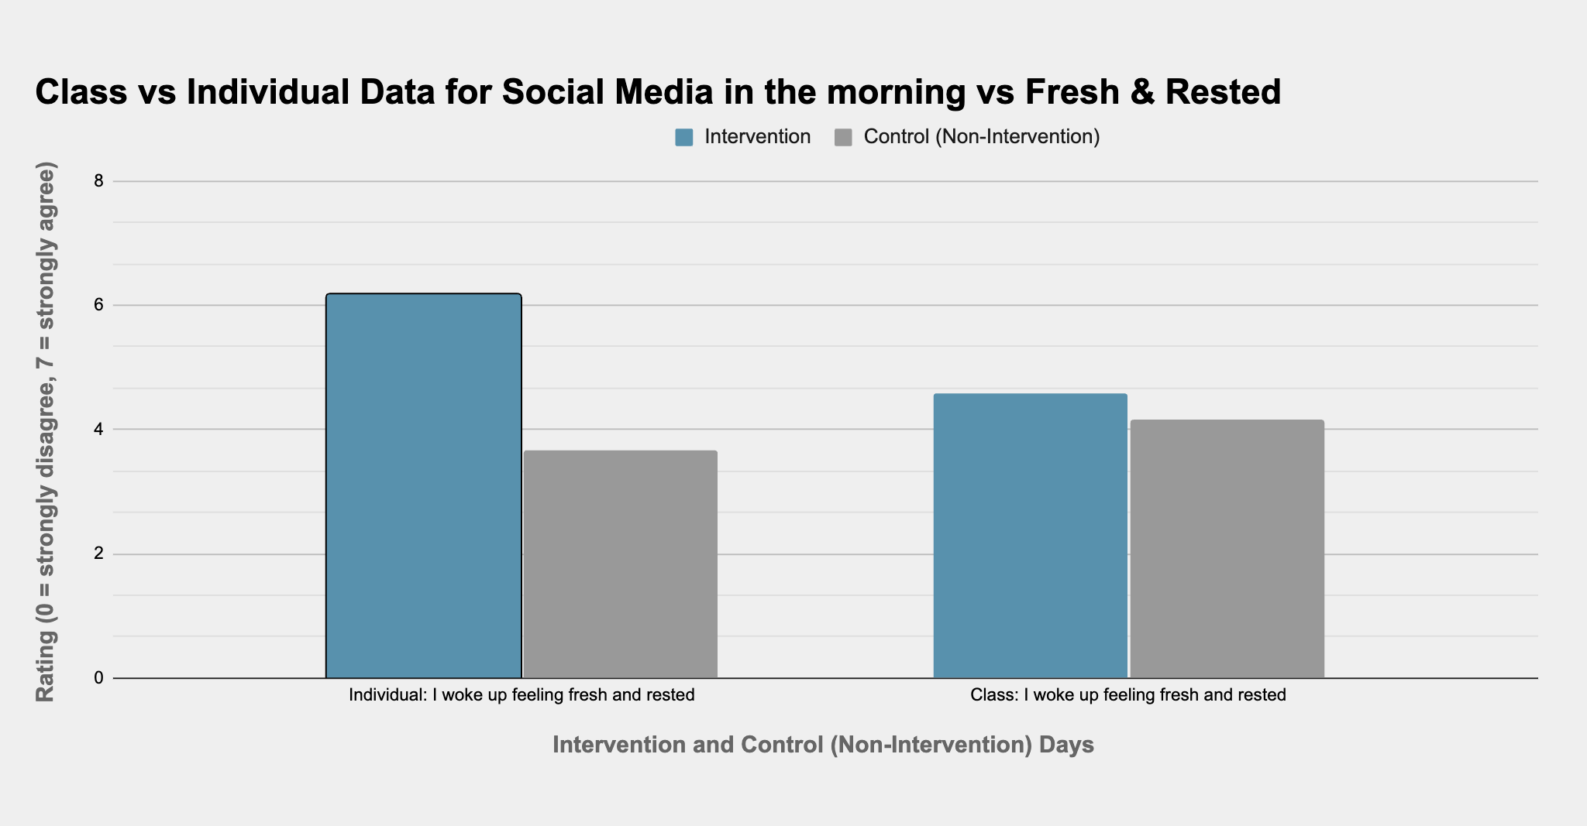

On days I didn't use social media when I woke up how fresh and rested I felt throughout the day had a mean of 6.167 and standard deviation of ​​0.373, as compared to on the days I did the score was at 3.67 and the standard deviation was 0.943. Due to this being a self-designed intervention, we can’t directly compare class data with individual data. Nevertheless having the data could prove useful. Class data for the intervention had a mean ‘I woke up feeling fresh and rested’ score of 4.58 on intervention days and a mean score of 4.16 on control days.

**Discussion**

1. **Exercise**

The results from my exercise intervention align with my hypothesis, suggesting that a moderate duration of physical activity—60 minutes in this case—can positively affect how fresh and rested I feel the next morning. The observed increase in how fresh and rested I felt from an average rating of 4 to 5.67 underscores the beneficial impact of exercise, even if it's not a drastic change. This finding is consistent with existing literature, such as the study by Saidi et al. (2021), which highlighted the positive effects of regular exercise on sleep quality and overall well-being. These improvements in sleep quality and well-being could be linked to the enhanced feelings of freshness I experienced. The comparison between my personal data and the larger class dataset also offers additional insights. While my individual data showed a 1.67 increase in feelings of freshness and restfulness, the class data, with a larger sample size, reported a smaller, yet consistent, increase from 3.73 to 4.29. This smaller change in the class data could be attributed to the larger sample size, which tends to average out individual variations. The identical standard deviation of 0.557 for both intervention and control days in my exercise study is intriguing. It implies a uniformity in the variability of feeling fresh in the morning, regardless of exercise. Additionally, my personal experience during this experiment suggests a positive correlation between exercise, improved feelings of being active, and of productivity, which aligns with research indicating the mental health benefits of physical activity. This consistency between my findings, class observations, and previous research supports the idea that exercise can enhance mental health and contribute to feeling more refreshed in the morning.

1. **Social Media before bed**

The results of the social media before bed intervention reveal a substantial effect on morning freshness. My personal data showed a significant decrease in feelings of freshness, with a mean of 6.33 without social media dropping to 3.33 with its use, maintaining a consistent standard deviation of 0.47. This stark contrast reinforces the hypothesis that pre-sleep social media use is detrimental to sleep quality. In contrast, class data showed a less dramatic change, with means of 4.07 and 4.17 for intervention and control days, respectively. The subtle difference in the class data could reflect diverse individual responses to evening social media usage. Both data sets, however, suggest a trend where pre-bedtime social media engagement might adversely affect how fresh and rested one feels in the morning aligning with Kazhali's 2021 study, which highlights the negative impact of pre-sleep social media use on sleep quality. My personal experience suggests that using social media before bed could also negatively affect my mood and how calm and relaxed I feel the next. The consistency between these findings and Kazhali's study underscores the potential detrimental effects of nighttime social media on sleep quality and overall well-being.

1. **Social Media in the morning**

The results from the morning social media intervention distinctly show a negative impact on how fresh and rested I felt. There was a significant drop in my average feelings of freshness from 6.167 on non-social media days to 3.67 when social media was used. This decrease highlights the strong influence morning social media engagement has on my sense of restfulness and overall morning vitality. The notable increase in standard deviation on days when social media was used in the morning (0.943) compared to control days (0.373) suggests a significant fluctuation in how fresh and rested I felt. This variability could be indicative of how different aspects of morning social media use, such as content type or duration, uniquely affect my morning freshness. This is consistent with the systematic review by Alonzo, Hussain, et al. (2021), linking excessive social media use to poorer sleep quality and negative mental health outcomes, particularly in youth. On the other hand, class data showed a slight increase in mean freshness feeling from control and intervention days but this can be atrributed to the self-designed nature of the intervention, where other’s couldve designed interventions aimed at increasing these feelings, rather than exploring factors that might negatively impact them.

**Limitations**

In examining the limitations of my interventions, it's crucial to acknowledge the influence of confounding variables. The substantial increase in standard deviation during the social media intervention mornings suggests external factors significantly impacting the outcomes. Variables such as overall screen time, physical health, and special events like Thanksgiving could have contributed to this variability.

For all interventions, the timing of the intervention itself was a crucial factor. The exercise intervention coincided with a period when I was more socially active, potentially influencing the results. The intervention involving social media before bed occurred just before my midterms, a time likely marked by increased stress and disrupted sleep patterns. The third intervention, right before finals, also spanned two weeks, capturing a period of potentially high stress and irregular routines.

The degree to which I felt fresh and rested upon waking was likely influenced significantly by sleep duration and quality. These aspects of sleep are known to be affected by a variety of factors, including stress, physical activity, and screen time. A scoping review in Sleep Science and Practice confirms that such lifestyle factors, particularly nutrition and physical activity, have a considerable impact on sleep quality, which in turn affects morning freshness (Alruwaili et al., 2023). This aligns with the observed variations in my study across different intervention periods.

To fully understand the impact of these interventions, it's essential to consider these confounding variables and their potential effects on the outcomes.

In conclusion, for me, the most effective intervention was exercise, which significantly improved my feelings of freshness and restfulness, whereas the least effective was using social media in the morning. For the class, interventions designed to increase positive feelings showed more effectiveness, possibly due to a focus on positive lifestyle changes. The most enjoyable aspect was the exercise routine, as it also positively impacted my mood and overall well-being. Moving forward, I plan to continue with regular exercise, hoping it will further enhance my sleep quality and daily productivity. For future directions, focusing on optimizing sleep hygiene and exploring the impacts of diet on sleep quality could be beneficial.

**Works Citied**

Saidi, O., Colin, E., Rance, M., Doré, E., Pereira, B., & Duché, P. (2021, June 15). Effect of morning versus evening exercise training on sleep, physical activity, fitness, fatigue and quality of life in overweight and obese adults. Chronobiology International, 38(11), 1537–1548. <https://doi.org/10.1080/07420528.2021.1935988>

Al Kazhali, M., Shahwan, M., Hassan, N., & Jairoun, A. A. (2021, October 23). Social media use is linked to poor sleep quality: The opportunities and challenges to support evidence-informed policymaking in the UAE. Journal of Public Health, 45(1), 124–133. <https://doi.org/10.1093/pubmed/fdab372>

Alonzo, R., Hussain, J., Stranges, S., & Anderson, K. K. (2021, April). Interplay between social media use, sleep quality, and mental health in youth: A systematic review. Sleep Medicine Reviews, 56, 101414. <https://doi.org/10.1016/j.smrv.2020.101414>

Alruwaili, N. W., Alqahtani, N., Alanazi, M. H., Alanazi, B. S., Aljrbua, M. S., & Gatar, O. M. (2023, October 21). The effect of nutrition and physical activity on sleep quality among adults: a scoping review. Sleep Science and Practice, 7(1). <https://doi.org/10.1186/s41606-023-00090-4>